Professional Nurse Advocate
Crib Sheet

Group
Start Time
Introduction of session | Maybe show poster/background to PNA
Establish Ground rules/safe space agreement | Formal, Confidential, Time Bound, Safe quiet space, away from clinical area, Leave feeling better than we came in, Respect, Non-judgemental, Listening, accepting view point of others, help to bring focus and clarity to some important themes, Participatory, Themes what do the group want us to do with them, No phones, no food or drink, no notes, What here for and what not here for
Grounding exercise (optional) | 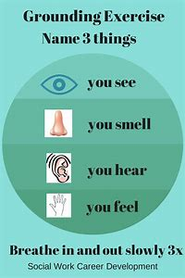
Check In | Facilitator goes last (to reduce negativity)  Each person should have no more than 2 mins to share feelings- focus on feelings/emotions not events.  Examples;  colours what colours represents how you feel and what does that colour mean to you?  How might your closest friend describe how you feel today?  Could use emojis/other cards  This enables you to identify any shared emotions & where the group would like to focus the reflective discussion.
Reflective Discussion | After check in go around group again and ask what they are finding emotionally difficult give each individual 3-4 mins (need to consider time and controlling the group)  Recognise individuals’ strengths and challenge their unhelpful personal expectations  If someone is struggling can go around the group and ask for each individual to offer 1 thing which may help the person move forward.  Could try positive reframing, examples;  Now consider some of the themes discussed  Response to things shared /Action planning for next meeting  Support if a service improvement is involved  Where do you share themes – do group consent?
Check Out | If feeling worse than before – sorry that they feel that way/further support required?  Don’t offer 1:1s in front of whole group
End Time

