LIFE LINES

HOW TO USE ATOUCHAWAY™ FOR ICU FAMILY VIRTUAL VISITING/MEETINGS AND COMMUNICATION WITH THE ICU/WARD TEAM

BACKGROUND:
The aTouchAway™ platform enables your ICU/WARD team to establish virtual family visiting and communication. aTouchAway™ can be used on multiple tablets for a given unit with admitted patients added to each tablet with their circle of family member contacts.
Any ICU/WARD staff member can use any one of the ICU/WARD assigned tablets with ATouchaway to connect virtually with family members by simply selecting the patient and the appropriate family member. If you have multiple ICUs/WARDS, you can configure groups of tablets for each location. If patients move from one physical location to another, patients can be transferred to tablets assigned in the new location.
The diagram below provides you with a generic view of what your organization will look like assuming you have several clinical units where the ICU/WARD team needs to connect to family members.

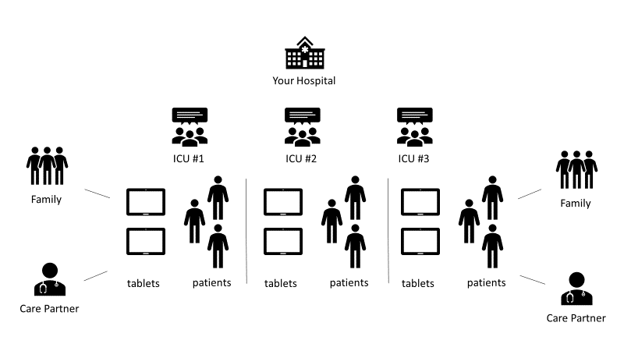

INITIAL SET UP/ CONFIGURATION FOR FIRST USE
- Provide your organization name, contact person name, email and phone number to the aTouchAway™ team  - The aTouchAway™ team will send organization specific logins for each tablet (e.g., Tablet 01@stelsewhere) as well as admin logins (e.g. Admin1@stelsewhere), all with 1 generic password  - Switch on the device and enter the 4572 PIN then press OK  - Click on the aTouchAway™ app  - Sign in to Atouchaway on each tablet with 1 of the provided tablet logins (i.e. Tablet 1 logs in with Tablet 01@stelsewhere; Tablet 2 logs in with Tablet 02@stelsewhere etc)  - Disregard the need to check a verification email, the tablet is now fully functional  - Affix a numerical label to each e.g., Tablet 1, Tablet 2 etc that corresponds with the tablet login number  - We recommend affix COVID19 stickers to chargers and charging cables to prevent lose  - We recommend the PIN and tablet login is stored in your electronic health record or other locations – do not affix to tablet to prevent unauthorized users logging in and accessing family members.  - Your tablets are now set up  1. Download aTouchAway™ for the desktop/laptop computers that will be used with admin logins from https://aetonix.com/download/ (select download Windows or Mac)  2. Log in to aTouchAway™ on admin designated desktop computer using one of the admin logins provided  - Your organization is now set up! | 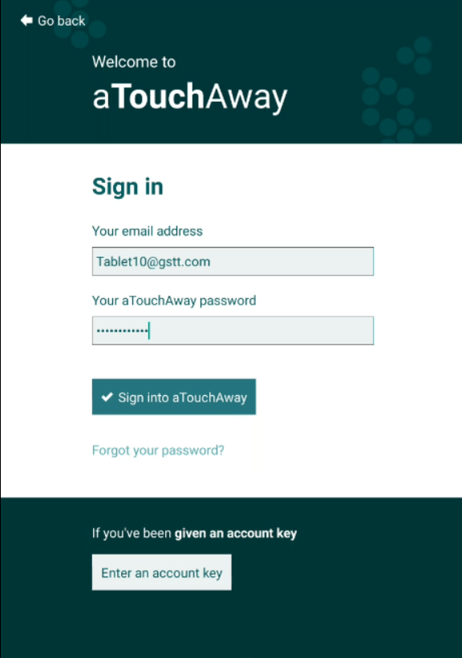

HOW TO ONBOARD PATIENTS
- Tap on the Organization tab at the bottom of the screen (tablet). (can also be done on desktop enabled with ATouchaway) | 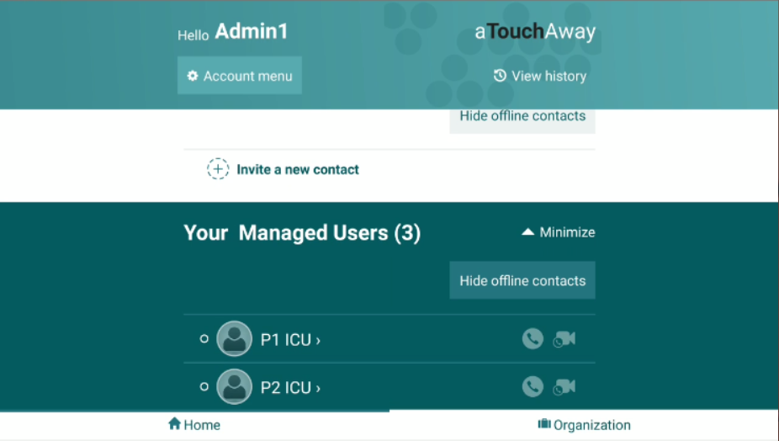
- Tap on the Creation & Token button

- Tap on create on the top right of the screen | 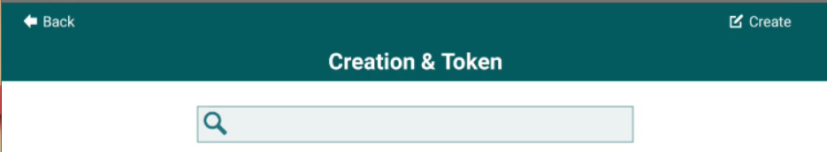
- Enter patient first & last name  - Under Default Managers add all the admin and tablet accounts that you will use in the ICU location (e.g., admin1, admin2, tablet 1, tablet 2 etc) using the default list from your default manager pick list or the tablet login address (e.g. Tablet 01@stelsewhere) – this enables all patients to be viewed on all tablets  The tablet you are using MUST be added in the Default manager  - Leave Patient EMR blank  - Leave ‘invite by email’ turned off  - Tap Save | 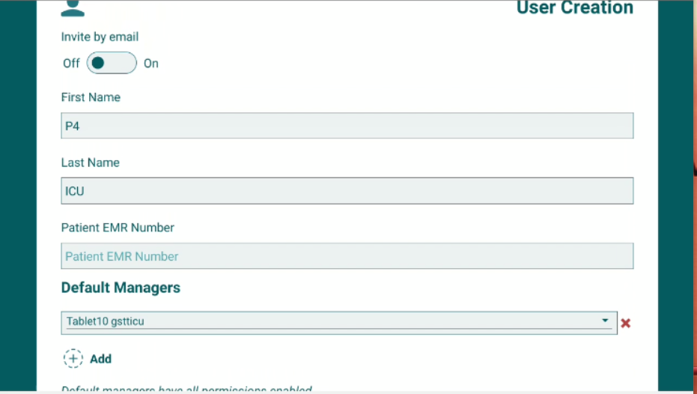
- Your patient is now added !– repeat for other patients across your organisation that need to be added at this time | 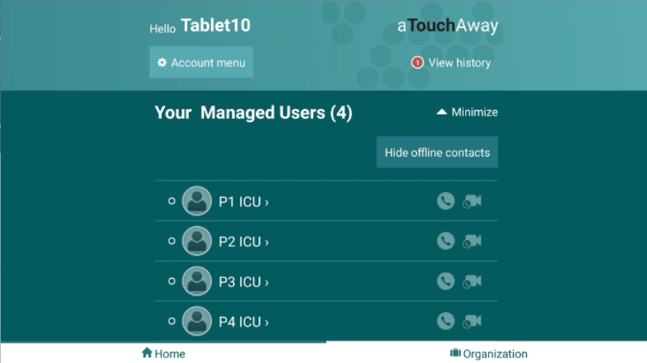
HOW TO CREATE THE PATIENT’S FAMILY CIRCLE
- Tap on the aTouchAway™ Home tab at the bottom of the screen and scroll down into the green area to select your patient
- Tap on Contacts | 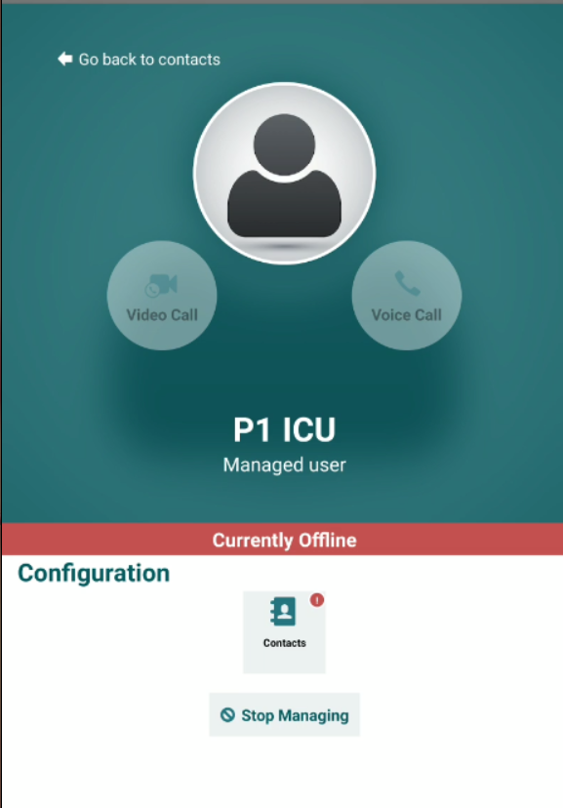
- Invite new contact | 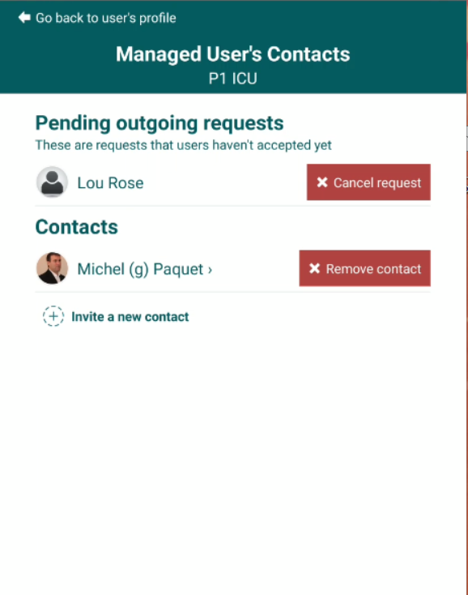
- Enter the email address of the next of kin/family member you want to invite – and then tap on send request.
- The email address needs to be entered precisely. This step generates an invitation to the recipient to download the aTouchAway app.

TIP: routinely record next of kin email addresses at time of admission
- Once the family member has received the invitation email, downloaded the app, enrolled themselves on the app and accepted the contact request, they will appear as a contact for that patient. (see ‘Setting Up Your Family’ section)

SETTING UP FAMILY TO RECEIVE COMMUNICATION FROM ICU/WARD TEAM
- The family member receives an invitation email to register with aTouchAway™  - Once registered, the family receives instructions on how to install the aTouchAway™ App. They MUST sign in using the same email they provided to the clinical team | 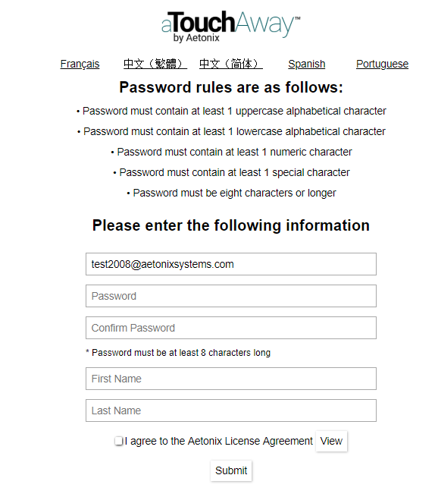
 | 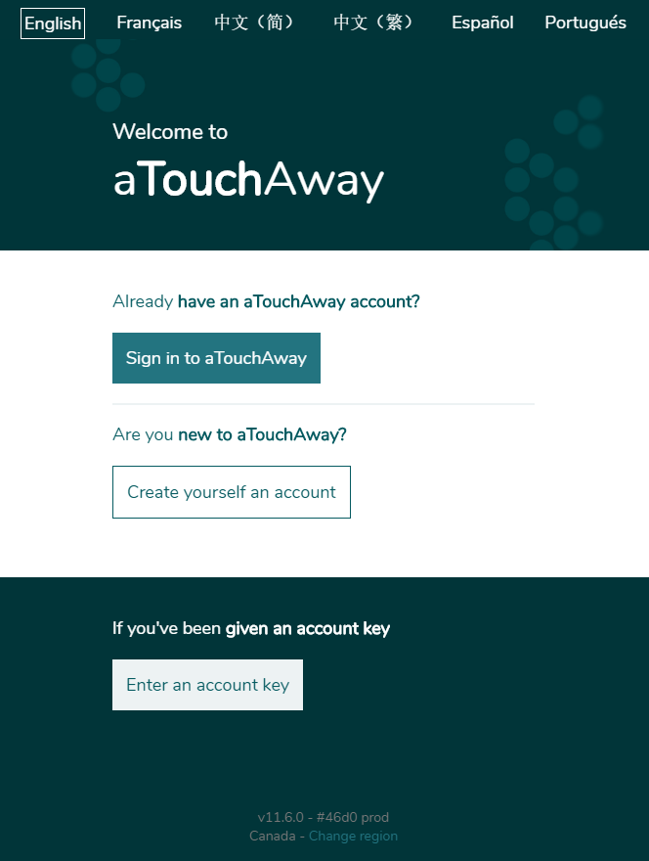
- Once signed in, there will be a Contact request on the home page  - Tap accept  - The family member is now linked as a contact for the named patient | 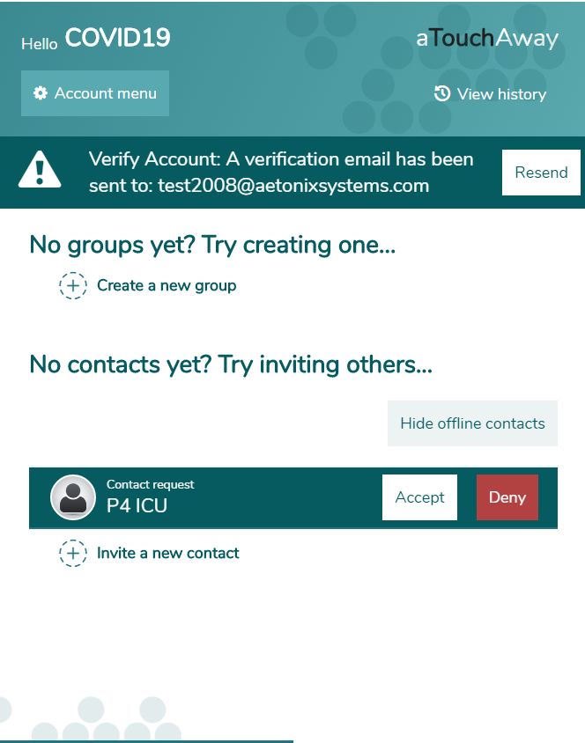
aTouchAway™ is available from the App or Android store (mobile devices) or from https://aetonix.com/download/ for PC or Mac | 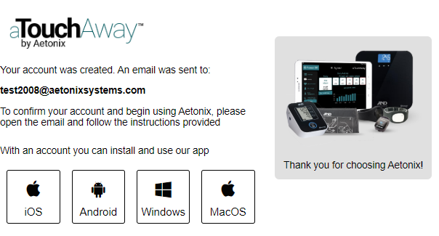

HOW TO COMMUNICATE WITH A PATIENT’S FAMILY
- Using a tablet installed with aTouchAway™ , go to ‘Home’ tab and scroll down to the green area.
- Tap on your patient

- Tap on Contacts
- Tap on the family contact you wish to connect with | 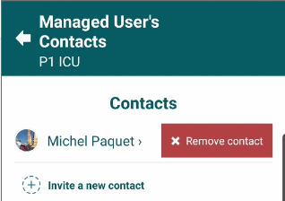
- Tap on the messaging, voice call or video call button  - Make sure the camera is working bidirectionally i.e. not selfie only | 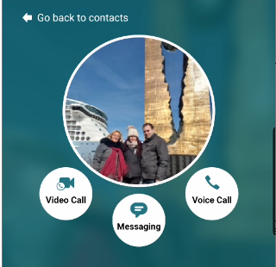

HOW YOUR FAMILY CAN COMMUNICATE WITH THE ICU/WARD TEAM

1. The family member signs into the aTouchAway™ app on their smartphone (or desktop/Mac) using their email and password
2. Click on the messaging button to send a text message and type message
3. Family members will only be able to use the messaging function; audio and video functions have been disabled for family. Video or audio calls will be initiated by ICU/ward team only.

Please note that the content of video and audio calls is NOT recorded by aTouchAway™.

Suggested Guidelines for conducting a video call
- Schedule time of call with family using phone or messaging function.
- Begin call with camera facing staff (selfie setting) and introduce yourself.
- Request family password at start of video or audio call. We recommend routinely setting up passwords for each patient on admission to the ICU/ward which can be used to verify identity of visitors and prevent unwanted contacts.
- Check who all the participants are on the call.
- Remind family that screengrabs and screen recording is forbidden. This is to protect the patient. Reassure visitors that this is a secure video link, with minimal risk of breach, but we cannot be responsible for any ‘screengrabbed’ content.
- For first-time callers, staff should prepare family for the sight of their loved one intubated/ventilated/sedated.
- Then flip camera to view the patient. Provide commentary about what the family are seeing, orientate to the sights and sounds of the ICU/clinical area as you would if the family were present in the room.
- Answer any questions.
- Family should be encouraged to speak to a sedated patient so bring tablet close to the patient.
- Throughout the call, take great care to prevent the camera from inadvertently capturing other patients or clinical areas.
- Close the call.
- It is best practice to document the call, participants and summary of content. Indicate it is linked to COVID-19 service support.

1.If a family member sends a text message when a clinical team member is using the tablet for the patient, the message can be seen and can be responded to.  Please note that clinical staff should refrain from disclosing personal details or detailed clinical information via the messaging function.  We recommend that the messaging function be used to schedule video/audio calls and other brief updates only. It should NOT be used to communicate changes in patient condition or potentially distressing news. | 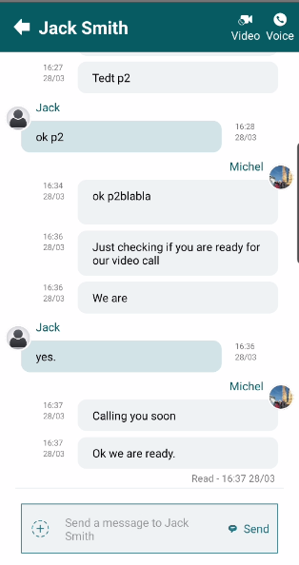
4. If a family member sends a message when the clinical team is not available, the ‘view history’ button on the home page will display a red dot for notification purposes. Press this icon to view.  5. Click on the message icon to access to the message. | 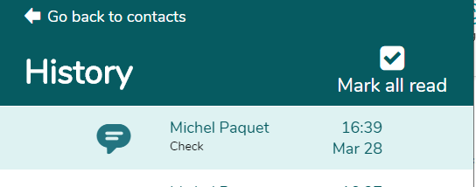

STEP 6: HOW TO DELETE A PATIENT
1. Type in the URL dashboards.uk.aetonix.xyz/ using Chrome
- On the login page, log in using one of the admin logins | 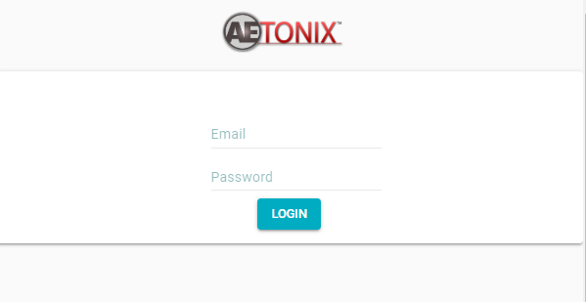
- Click on ‘User Management’ on the dashboard  - Click on ‘Creation/Token’ | 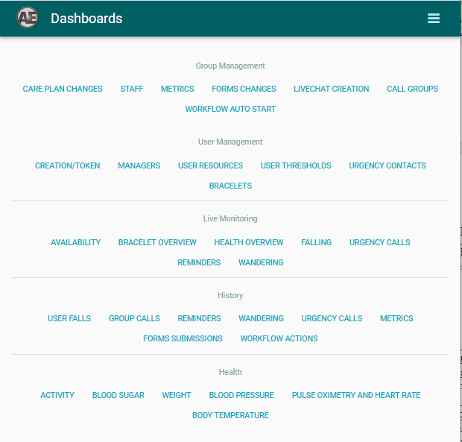
- Identify the patient you want to delete  - Click on the symbol. and confirm.  - The patient is PERMANENTLY deleted from aTouchAway™ and the references to family account are removed. | 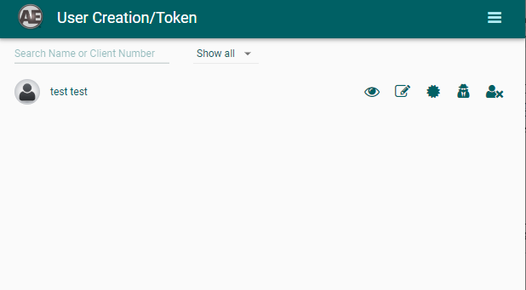

FAQs
Does the patient need to have given consent for video/audio call?
No, this modality is being used in the best interests of non-capacitous patients in ICUs and general wards, unless the family have indicated that the patient would object to video/audio linkage. A best practice recommendation is for the intubation team to pre-consent patients for use of family video calling, and document this.

